**XTM Anonymization**

# Introduction

The anonymization feature identifies confidential personal data such as names, proper names, dates, addresses, telephone numbers, email addresses, URLs as well as any numeric values and replaces them with a placeholder. When the text goes for either manual translation, or machine translation, there is no risk that confidential information will be leaked. When the localization is complete and the target document is recomposed, the confidential data is automatically reinserted into the text. The feature is currently available for English, French, German and Italian source texts.

# Usage

The use of anonymization must first be enabled in the system settings, and becomes an available option for each project created afterwards  
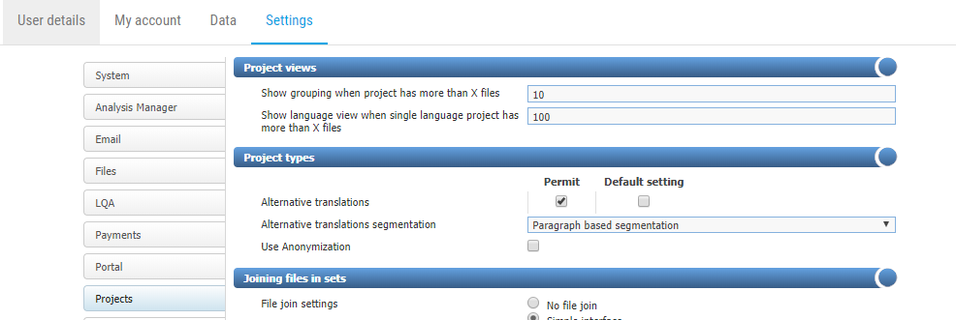

Anonymization can be used for any MS Word files prior to import in XTM for translation and has three different available configurations:

1. **POS (Part Of Speech) recognition:** This configuration requires no source file modifications or use of a specific style, and POS are automatically identified and converted to placeholders. Using POS recognition is likely to also identify parts of the text that are not to be excluded and is to be used with caution
2. **Use the 'anon' style**: Using this style to mark-up proper nouns etc. that you wish to anonymize before importing the fie to XTM for translation. XTM will also automatically anonymize numerics, email addresses and web addresses
3. **Use the ‘onlyanon’ style**: Using this style to mark-up content to be anonymized with anything else remaining translatable

## Source Document

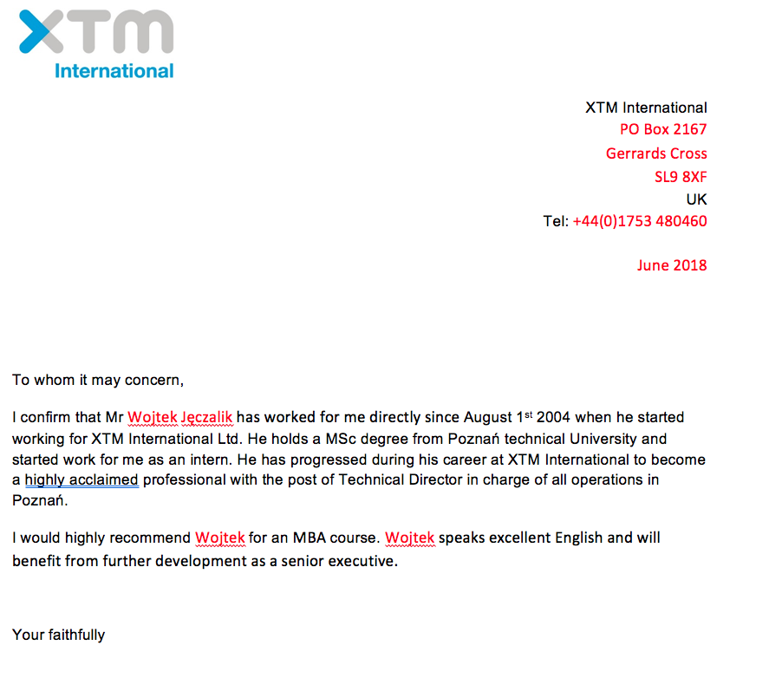

## Anonymized in XTM Editor

